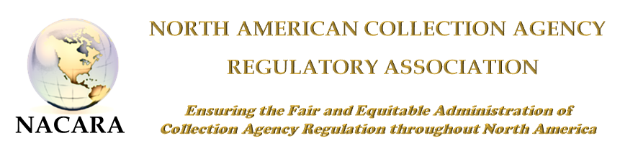
2018 NACARA ANNUAL CONFERENCE & TRAINING EVENT
AGENDA
October 15 - 17, 2018
Holiday Inn – Downtown Charleston - Charleston, SC
425 Meeting Street, Charleston, South Carolina
1-843-781-2327
All sessions will be in Peninsula Ballroom
Monday, October 15, 2018 – Regulators Only*
7:00 – 8:00 am | Registration
8:00 – 8:30 am | Welcome & Opening Remarks  Liz Benotti, President of NACARA  Carrie Grube-Lybarker, South Carolina Dept. of Consumer Affairs Administrator
8:30 – 10:30 am | Kinesic Interview and Interrogation – Part II  Christopher Holland, Holland & Associates
10:30 – 10:45 am | Break
10:45 – 12:00 pm | Nationwide Multistate Licensing System (NMLS)/Vision 2020  Tim Doyle, Senior VP, Policy and Development, State Regulatory Registry (CSBS)
12:00 – 1:00 pm | Lunch
1:00 – 2:00 pm | General Session – Eldercare & Debt Collection  Antonio ‘Tony” P. Salazar, Maryland Commissioner of Financial Regulation
2:00 -3:00 pm | Federal Trade Commission Update  Tom Carter, Senior Attorney, Southwest Regional Office
3:00 -  3:15 pm | Break
3:15 – 4:00 pm | Business Meeting & NACARA Elections
4:00 -5:00 pm | Regulator Roundtable – Part I  Jedd Bellman, Assistant Commissioner for Non-Depository Supervision in the Office of the Maryland Commissioner of Financial Regulation and Vice-President of NACARA Moderator
6:30 -9:30 pm | Regulator Dinner* - Dinner Cruise  Spiritline cruises –“Spirit of Carolina”

Tuesday, October 16, 2018 - Regulators and Industry
8:00 -9:00 am | Registration & Meet the Regulator Breakfast
9:00 – 9:45 am | Licensing Board Discussion:  Similarities/Differences/Authorities/Board Make-Up  Peggy Matson, Executive Director of Arkansas State Board of Collection Agencies  Bradley Chapman, Chairman, Wyoming Collection Agency Board and owner of Attitude Collections, LLC,  Grace Hamilton, Investigator, Washington State Department of Licensing
9:45 – 10:45 am | WIDE-RANGING LEGISLATIVE, POLICY AND OPERATIONS OVERVIEW FROM THE PERSPECTIVE OF THREE LEADING TRADE GROUPS, FOLLOWED BY Q&A  Stephanie Eidelman, Chief Executive Officer, iA Institute  Andy Madden, Vice President of Government & State Affairs for ACA International  David Reid, Director of Government Affairs & Policy, Receivables Management Association
10:45 – 11:00 am | Break
11:00 – 12:00 pm | “Understanding Alzheimer Disease and How It Relates to Debt”  Sam Wiley, Vice President of Programs, Alzheimer’s Association
12:00 -1:00 pm | “Update on the BCFP’s Debt Collection Work, Including Rulemaking”  Luncheon Speaker  John McNamara, Assistant Director of Consumer Lending, Reporting & Collections Market, Bureau of Consumer Protection
1:00 -2:00 pm | Unraveling Healthcare Compliance  Leslie Bender, Chief Strategy Officer & General Counsel, BCA Financial Services
2:00 -3:00 pm | “How Technology Is Changing the Collections Terrain”  Tim Lange, Chief Operating Officer, Buckley Sandler, LLP  Kathryn L. Ryan, Partner, Buckley Sandler, LLP
3:00 -3:15 pm | Break
3:15 - 4:15 pm | Student Loan Servicing & Debt Collection  Chuck Cross, Senior Vice President of Consumer Protection and Non-Depository Supervision for the Conference of State Bank Supervisors  Stacey Serrano Staff Attorney, Consumer Credit Division, Connecticut Department of Banking
4:15 pm -5:00 pm | Multi-State Examinations, Multi-State Debt Collection Committee, & State Examination System  Anthony Polodori, Bureau Chief, Idaho Dept. of Finance, Consumer Finance Bureau  Kyle Thomas, Vice President of Accreditation and Supervisory Processes at the Conference of State Bank Supervisors  Tony Vasile, Senior Director of Non-Depository Supervision for the Conference of State Bank Supervisors
6:00-8:00 pm | Networking Reception – Industry & Regulators

Wednesday, October 17, 2018 – Regulators Only and Industry*
8:00 – 9:00 am | BREAKFAST
9:00 - 10:00 am | Legislative Update, Etc. – Outdate Laws And Unintended Consequences  Manny Newburger, Barron & Newburger, P.C.  Nathan D. Willner, Lyons, Doughty and Veldhuis, P.C.
10:00 -11:00 am | “The Commercial Conscience – Financial Accountability Is Just the Beginning”  Manny Newburger, Barron & Newburger, P.C.  Annette Waggoner, Executive Director of Commercial Collection Agencies of America
11:00 - 12:00 noon | Regulator Roundtable – Part II*  Jedd Bellman, Assistant Commissioner for Non-Depository Supervision, Office of Maryland Commissioner of Financial Regulation Vice-President of NACARA Moderator
12:00 noon | Adjourn – Travel

*Regulator only session

