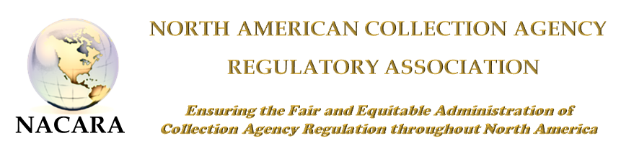
2017 NACARA ANNUAL CONFERENCE & TRAINING EVENT
AGENDA
October 2 - 4, 2017
Embassy Suites - Bellevue
Bellevue, Washington
Monday, October 2, 2017
7:15 AM | Registration
8:00 – 8:30 | Welcome & Opening Remarks  Kathleen Drew, Assistant Director – Business & Professional Director, State of Washington Dept. of Licensing  Elizabeth Benotti, President, NACARA
8:30 – 10:15 | General Session  Interview Techniques  Christopher Holland from the D. Glenn Foster Program
10:30 – 10:45 | Break
10:45 – 12:00 | General Session  Investigations vs. Examinations – Panel Discussion  Moderator – Kurt Johnson, State of MN  Grace Hamilton, WA Investigator  Garrett Young, MA Examiner
12:00 – 1:00 PM | Lunch
1:00 – 3:00 | General Session  Roundtable Discussion  Moderator – Jedd Bellman, State of Maryland
3:00 – 3:15 | Break
3:15 – 4:30 | General Session  Federal Trade Commission  “Initiatives Together”  Tom Carter, Senior Attorney
4:30 – 5:00 | General Session  Questions/Comments on the Day/Surveys  Elizabeth Benotti, President, NACARA
5:30-7:30 | Welcome Reception & Registration  Embassy Suites Atrium
Tuesday, October 3, 2017
8:00 AM | Registration
8:30 – 9:00 | General Session –  CSBS – Nationwide Mortgage Licensing System (NMLS)  Tim Doyle, Senior Vice President, CSBS
9:00 – 10:00 | General Session –  21st Century Debt Collection in a  20th Century Regulatory Framework Presented by David Cherner – Moss and Barnett, P.A. and Tim Bauer, President, Inside ARM
10:00 – 10:15 | Break
10:15 – 11:00 | General Session –  Commercial vs Consumer Collections  Sheryl Sailer, ND and Annette Waggoner, AALC – Commercial
11:00 – 12:00 PM | General Session -  How Your Regulatory Exams Can Provide More Opportunities for the Regulator, the Examined Agency and the Consumer.”  Presenters: Tim Collins –General Counsel for Convergent Outsourcing and John Rossman - Moss and Barnett, P.A.
12:00 – 1:00 | Lunch
1:00 – 2:00 | Consumer Financial Protection Bureau (“CFPB”)  Jack Newman, Office of Supervision Policy  Discussion of how they determine their exam schedule/risk factors and any bureau updates
1:45-2:45 | Cyber Security –WA Federal Bureau of Investigation  Ethan Via, Special Agent  Spotting, Reporting, and Preventing Fraudulent Schemes
2:45-3:00 | Break
3:00 – 4:30 | Unintended Consequences-Bank Accounts; Net Worth; Technology; Account Recalls  Presented by: Kelly Knepper- Stephens, General Counsel and CCO for Stoneleigh Recovery Associates, LLC and Manny Newburger – Barron & Newburger, P.C.
Wednesday, October 4, 2017
8:00 – 9:00AM | Business Meeting & NACARA Elections *
9:00 – 10:00 | Multi-State Examinations/Investigations  Anthony Polidori, Supervising Examiner  State of Idaho
10:30 – 12:00 | Regulator Roundtable*  Jedd Bellman, Moderator,  Assistant Commissioner, State of Maryland
12:00 PM | Adjourn – Travel

